**A PROJECT REPORT**



**ON**

**“Online Movie Ticket Booking System”**

**SUBMITTED TO SAVITRIBAI PHULE PUNE UNIVERSITY**

**IN**

**PARTIAL FULFILLMENT OF THE REQUIREMENT FOR THE AWARD OF THE DEGREE OF BACHLOR OF BUSINESS ADMINISTRATION**

**(COMPUTER APPLICATIONS) (BBA (CA))**

**SUBMITTED BY**

**NAROTE SAKSHI SURESH**

**MAGAR PAYAL CHHABURAO**

**NEW ART’S COMMERCE & SCIENCE COLLEGE SHEVGAON, AHMEDNAGAR 414502**

**BATCH 2023-2024**

NEW ART’S COMMERCE & SCIENCE COLLEGE, SHEVGAON

**Tal Shevgaon, Dist. Ahmednagar, Pin-414502(Maharashtra)**

**Tel. No. 02429-222593, (F) 02429-221267**

[**Email:newartsshevgaon1@yahoo.co.in**](mailto:newartsshevgaon1@yahoo.co.in) **Web:** [**www.newartscollegeshevgaon.com**](http://www.newartscollegeshevgaon.com/)

**Date:** -

# CERTIFICATE

This is to certify that Project entitled,“ **Online Movie Ticket Booking System**” being submitted here with for the internal work of the degree of BACHELOR OF COMPUTER APPLICATION (SEM-IV) to New Arts Commece and science College , Shevgaon is the result of the original project work completed by  **NAROTE SAKSHI SURESH & MAGAR PAYAL CHHABURAO** under the supervision

And guidance of Prof. M. B. Ghodechor & Prof. A. B. Shaikh.

**Date :**

**Place :**

**Prof. M.B. Ghodechor**

**Prof. A.B Shaikh Dr. Y.S.Sudake**

**Project Guide Head Of Department**

**Internal Examiner External Examiner**.

# Acknowledgement

We express our deep gratitude and sincere thanks to **Prof. M.B Ghodechor & Prof. A.B. Shaikh** for giving us an opportunity to undergo our project and also for giving proper co-operation, guidance, inspiration and helpful suggestion to prepare this project work.

We would also remain indebted to **Dr. Sudake Y. S. H.O.D Department of Computer Application** for providing the infrastructure and facilities needed to pursue this course and also giving kind of guidance and suggestion for completing the project work.

We are also thankful to **Prof** **M.B Ghodechor** & **Prof. A.B. Shaikh** who is the professor.

We also thankful to our parents who providing their wishful support for our project completion successfully.

Lastly, we are thankful to our classmates and friends for their direct or indirect contribution in the completion of work.

**Thanking you,**

Name of Student

**Magar Payal Chhaburao**

**Narote Sakshi Suresh**

# Index

|  |  |  |  |
| --- | --- | --- | --- |
| **Chapter No.** |  | **Details** | **Page no** |
| **1** |  | **Introduction** | 1 |
|  | 1.1 | Company profile | 2 |
|  | 1.2 | Existing system and need for system | 3 |
|  | 1.3 | Scope of work | 4 |
|  | 1.4 | Operating environment hardware and software | 5 |
|  | 1.5 | Detail description of technology used | 6 |
| **2** |  | **Proposed System** | 9 |
|  | 2.1 | Proposed system | 9 |
|  | 2.2 | Objectives of system | 11 |
|  | 2.3 | User requirements | 10 |
| **3** |  | **Chapter 03: Analysis and design** | 12 |
|  | 3.1 | Data-Flow Diagram | 13 |
|  | 3.2 | Use Case Diagram | 14 |
|  | 3.3 | Entity Relation Diagram | 15 |
|  | 3.4 | User Manual | 16 |
|  | 3.5 | Table Design | 17 |
|  | 3.6 | Test procedure& Implementation | 20 |
|  | 3.7 | User Interface(Screen shots) | 23 |
| **4** |  | **Sample Program Code** | 31 |
| **5** |  | **Menu Explanation** | 35 |

|  |  |  |  |
| --- | --- | --- | --- |
| **6** |  | **Drawbacks and limitations** | 37 |
| **7** |  | **Proposed enhancement** | 39 |
| **8** |  | **Conclusion** | 40 |
| **9** |  | **Bibliography** | 41 |

**CHAPTER 1:**

**INTRODUCTION**

**CHAPTER 1:**

**INTRODUCTION**

1.1 Introduction:

It provides the user to online browse and book movie tickets. With the increase in technology there has been lots of advancement in online booking system. Users are now able to see the seating plan and they can also book refreshments online. There are also systems through which users can confirm their ticket and pay while entering to the hall. Digitalization is one of the most amazing outcomes of technology. It has given easy accessibly of all the resources available.

Wasting time in the queues of movie theatre has been ruled out due to online system. Also, reviews can be easily read online so that user can get a clearcut picture about the movie. Online payment has also increased E-Banking which is helpful for the sound development of countries economy. Movie ticket booking in web is the process by which customer can purchase their movie tickets directly using internet and pay through online banking. Online movie ticket booking system is measurable, cost effective and has very good user interface. This web based PHP project provides the all working of cinema ticket booking system. Movie ticket booking in web is useful for both promoters and customers equally. Customers can make online movie ticket booking at any instance of 24 hours a day. And as this is a web based application therefore they can buy ticket from anywhere around the world. Customers can buy tickets without wasting their time. It includes is a user interface specification whereby the user can demonstrate interface standards to be used in designing the system. Furthermore, considerations regarding non-functional requirements and system evolution are addressed

**1.2 Existing system and need for system:**

**1.2.1 About existing system:-**

➤ Present System developed in asp In asp there are some limitations. It

is scripting language

It is very code complexity

➤ There is server controls in asp

➤ It Doesn't Support language interoperability

**1.2.2 Need for system:-**

➤ Software should be user friendly.

➤No one can interfere with software, except Customer, admin

**1.3 Scope of work:**

➤ The booking information is kept in a text database, which consists of combo cost, username, seat type, no of seats booked, ticket cost and net payable amount to be paid by the customer. This database is modified when the user books the ticket. The customer can be presented with a booking page, which allows them to add more of the same items or remove items from the combo items. The booking page also shows the seat type to be booked, no of seats to be booked, service charges to be applied, ticketing cost and net payable amount to the customer. When the customers have done their booking they will checkout using the payment information page. This page collects data about the customer, his bank name, his credit card number, credit card type, address, telephone number, mobile number. and CVV information.

**1.4 Operating environment hardware and software :**

Hardware requirements :

|  |  |
| --- | --- |
| Processor | Pentium-IV |
| Hard disk | 80 GB |
| RAM | 4GB |
| Monitor | Color monitor |
| Other  Hardware | Keyboard, Mouse  etc. |

Software requirements:

|  |  |
| --- | --- |
| Operating  System | Windows/Linux/ |
| Language | PHP , HTML, CSS  JavaScript |
| Database | MySQL |
| IDEL | Notepad/Notepad++  Xampp |

**1.5 Detail description of technology used:**

**PHP**

The term PHP is an acronym for PHP: Hypertext Preprocessor. PHP is a server- side scripting language designed specifically for web development. It is open- source which means it is free to download and use. It is very simple to learn and use. The files have the extension ".php".

Rasmus Lerdorf inspired the first version of PHP and participating in the later versions. It is an interpreted language and it does not require a compiler. PHP code is executed in the server.

It can be integrated with many databases such as Oracle, Microsoft SQL Server, MySQL, PostgreSQL, Sybase, Informix. PHP is an acronym for "PHP: Hypertext Preprocessor"

PHP is a widely-used, open source scripting language

PHP scripts are executed on the server

PHP is free to download and use

**HTML**

HTML (Hypertext Markup Language) is the set of markup symbols or codes inserted in a file intended for display on a World Wide Web browser page. The markup tells the Web browser how to display a Web page's words and images for the user. Each individual markup code is referred to as an element (but many people also refer to it as a tag). Some elements come in pairs that indicate when some display effect is to begin and when it is to end.

**CASCADING STYLE SHEET (CSS)**

Cascading Style Sheets (CSS) are a collection of rules we use to define and modify web pages. CSS are similar to styles in Word. CSS allow Web designers to have much more control over their pages look and layout. For instance, you could create a style that defines the body text to be Verdana, 10 point. Later on, you may easily change the body text to Times New Roman, 12 point by just changing the rule in the CSS. Instead of having to change the font on each page of your website, all you need to do is redefine the style on the style sheet, and it will instantly change on all of the pages that the style sheet has been applied to. With HTML styles, the font change would be applied to each instance of that font and have to be changed in each spot.

CSS can control the placement of text and objects on your pages as well as the look of those objects.

HTML information creates the objects (or gives objects meaning), but styles describe how the objects should appear. The HTML gives your page structure. while the CSS creates the "presentation". An external CSS is really just a text file with a .css extension. These files can be created with Dreamweaver, a CSS editor. or even Notepad.

The best practice is to design your web page on paper first so you know where you will want to use styles on your page. Then you can create the styles and apply them to your page.

**JavaScript**

JavaScript is a programming language commonly used in web development. It was originally developed by Netscape as a means to add dynamic and interactive elements to websites. While JavaScript is influenced byJava, the syntax is more similar to C and is based on ECMAScript, a scripting language developed by Sun Microsystems.

JavaScript is a client-side scripting language, which means the source code is processed by the client's web browser rather than on the web server. This means JavaScript functions can run after a webpage has loaded without COMMUNICATING with the server. For example, a JavaScript function may check a web form before it is submitted to make sure all the required fields have been filled out. The JavaScript code can produce an error message before any information is actually transmitted to the server.

Like server-side scripting languages, such as PHP and ASP, JavaScript code can be inserted anywhere within the HTML of a webpage. However, only the output of server-side code is displayed in the HTML, while JavaScript code remains fully visible in the source of the webpage. It can also be referenced in a separate JS file, which may also be viewed in a browser.

**CHAPTER 2:**

**PROPOSED SYSTEM**

**2.1 Proposed system:**

➤In this system, manager could browse the customer's document with the help of Some important goals of movie ticket booking are as follows:

➤Online cinema ticket booking system project is aimed to provide facility to book cinema tickets anytime and from anywhere.

➤One objective of this project is to minimize the no. of staffs at the ticket-box window.

➤ Promote new movies over the internet and gain maximum profit.

➤Provide a 24x7 service to the customer

**2.2Objectives of system:**

This section describes the objectives that achieved in the project.

1. The main objective is to make system design attractive and simple.

2. First objective is the understanding environment of database systems.

3. To make system easy to understand, user friendly and well coded.

4. Security and prevention of data from unauthorized access.

5. Ease to search information of Movies details.

6. System should have proper validation.

7. Ease to maintain data of database.

8. Ease to enter customer details.

**CHAPTER 3:**

**ANALYISIS OF DESIGN**

**3.1 Data-Flow Diagram :**

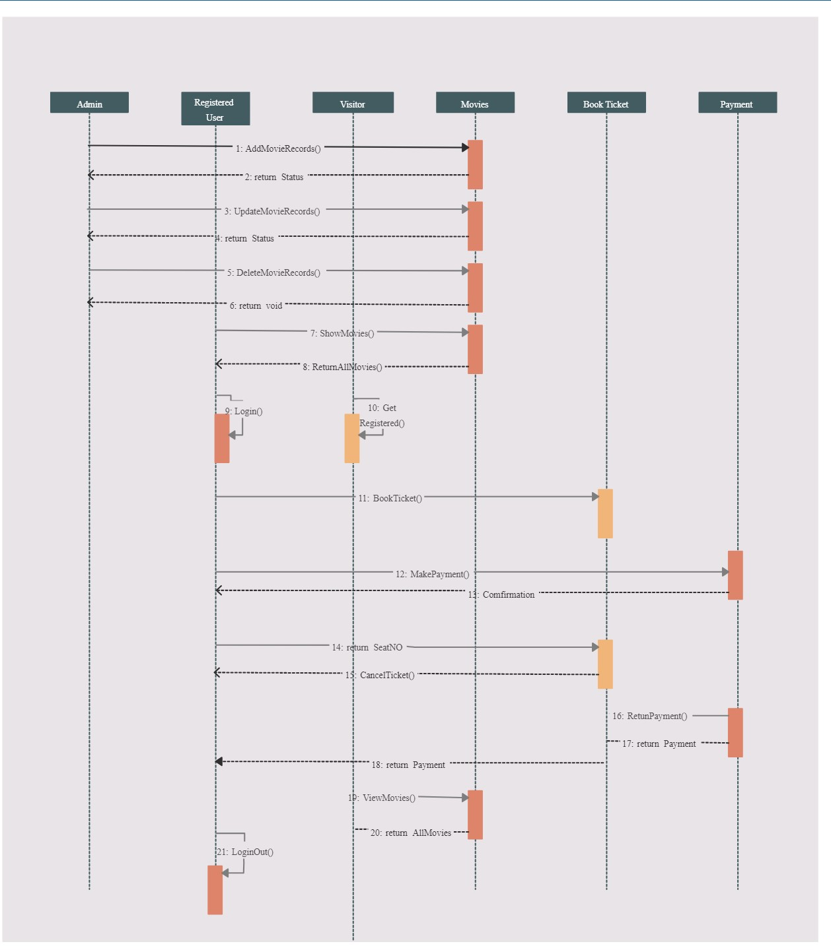

**3.2 Use Case Diagram :**

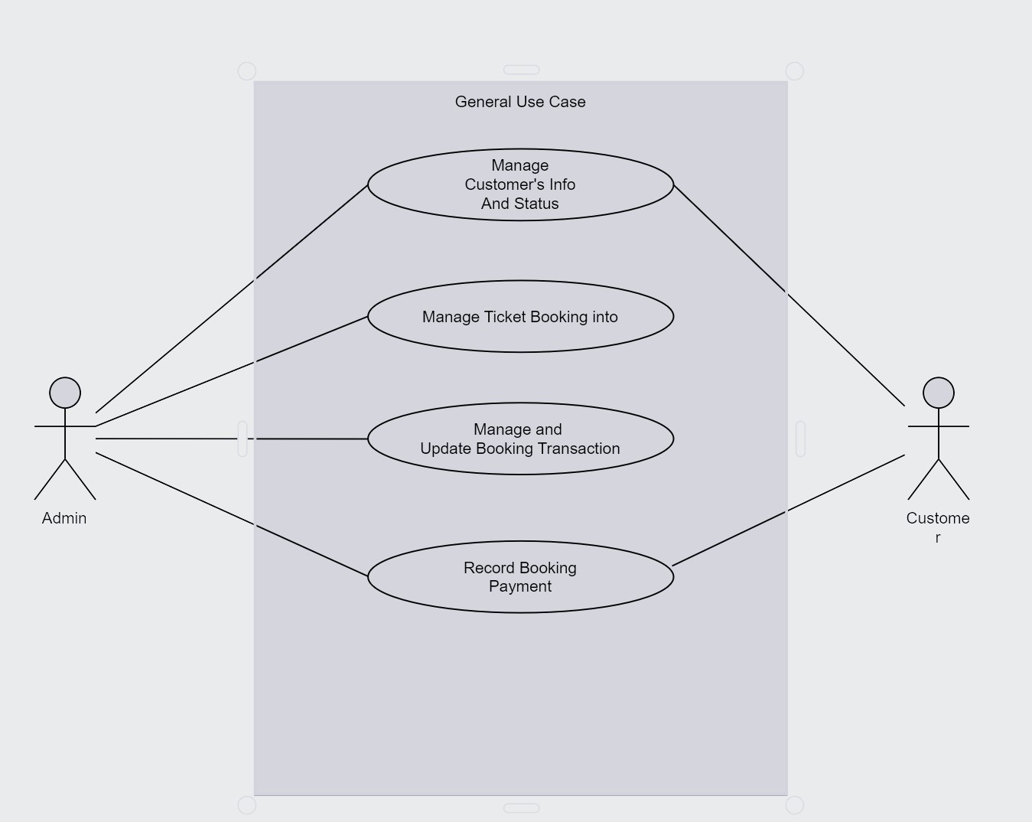

**3.3 Entity Ralation Diagram :**

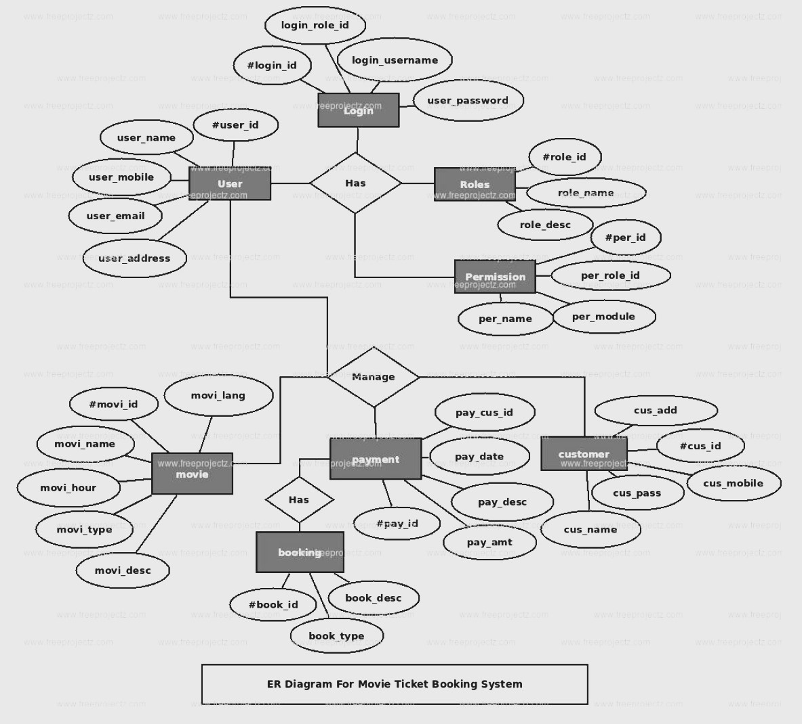

**3.4** **Use Manual :**

Getting Started

**Accessing the Platform**: Open your web browser and navigate to the website of the movie ticket booking platform. Alternatively, you may download the mobile app from the respective app store on your smartphone.

1. **Creating an Account**: If you're a new user, you'll need to create an account. Provide the required details such as your name, email address, phone number, and password. Follow the on-screen prompts to complete the registration process.
2. **Logging In**: If you already have an account, simply enter your login credentials (email/username and password) and click on the "Log In" button.

## Booking Process

1. **Selecting Location and Movie**: Upon logging in, you will be directed to the homepage. Use the search feature to find movies playing in your desired location. You can filter movies by genre, language, release date, etc.
2. **Choosing Showtime**: Once you've selected a movie, you'll see a list of available showtimes. Choose the showtime that suits you best.
3. **Selecting Seats**: After selecting a showtime, you'll be taken to a seating arrangement screen. Choose the number of tickets you want and select seats from the available ones. The selected seats will be highlighted.
4. **Adding Extras (Optional)**: Some platforms offer additional services or concessions like popcorn, drinks, or snacks. If you wish to purchase any extras, you can do so at this stage.
5. **Proceed to Payment**: After finalizing your seat selection and any extras, click on the "Proceed to Payment" button.
6. **Payment**: Choose your preferred payment method (credit/debit card, digital wallets, etc.) and enter the required payment details. Review the total amount and click on the "Pay Now" button to complete the transaction.

## After Booking

1. **Confirmation**: Once the payment is successful, you'll receive a confirmation email or message with your booking details and a QR code.
2. **Check-In**: On the day of the show, arrive at the cinema and present the QR code (either printed or on your smartphone) at the ticket counter or self-service kiosk to collect your physical tickets.
3. **Enjoy the Movie!**: With your tickets in hand, proceed to the designated theater hall and enjoy the movie.

## Additional Features

1. **Profile Management**: You can update your personal information, manage payment methods, view past bookings, and save preferences in your user profile.
2. **Notifications**: Stay updated with notifications about new movie releases, special offers, and upcoming events.
3. **Ratings and Reviews**: After watching a movie, you may have the option to rate and review it on the platform to share your feedback with other users.

**3.4 Table Design:**

1.Home Screen:

Welcome message and branding/logo.

Search bar to find movies by title, genre, or location.

Featured movies carousel or grid view.

2. Movie Listings:

Grid view of available movies with posters, titles, and ratings.

Filters to narrow down movie listings by genre, language, format, etc.

Sorting options (e.g., by release date, popularity, rating).

3. Movie Details:

Detailed view of selected movie with synopsis, cast, duration, and rating.

Showtimes displayed for various theaters

Option to select a showtime and proceed to booking.

4. Booking Process:

Seat selection interface showing theater layout and available seats.

Option to choose ticket quantity and seat preferences.

Review of booking details (movie, theater, showtime, seats, total amount).

Form for user information (name, email, phone number).

Payment options (credit/debit card, net banking, etc.).

Confirmation screen with booking details and QR code for ticket access.

**3.6 Implementation :**

1.Backend Development:

Set up a server-side environment using a web framework (e.g., Django, Ruby on Rails, Laravel).

Design and implement the database schema to store movie, theater, user, and booking data.

Develop RESTful APIs to handle CRUD operations for managing movies, theaters, bookings, and user accounts.

Implement user authentication and authorization mechanisms to secure sensitive operations.

2.Frontend Development:

Design the user interface for the web application using HTML, CSS, and JavaScript.

Create responsive layouts to ensure compatibility with various devices, including desktops, tablets, and smartphones.

Implement client-side logic for searching movies, selecting showtimes, booking tickets, and managing user accounts.

Integrate libraries or frameworks for enhanced functionality, such as interactive seat selection and real-time updates

3.Payment Integration:

Choose a payment gateway provider (e.g., Stripe, PayPal) and set up an account.

Integrate the payment gateway APIs to enable users to make secure online payments for ticket bookings.

Implement handling of payment status callbacks to update booking status and issue tickets upon successful payment.

4.Booking Workflow:

Develop the booking workflow to guide users through the ticket booking process.

Enable users to search for movies, view movie details, select showtimes, choose seats, and confirm bookings.

Implement validation checks to prevent double bookings, seat conflicts, and other errors.

5.User Management:

Implement user registration and login functionality to create and manage user accounts.

Provide features for users to view booking history, update personal information, and reset passwords.

6.Admin Panel:

Create an administrative dashboard for managing movies, theaters, bookings, and user accounts.

Implement features for adding, editing, and deleting movie listings, updating showtimes, and monitoring booking activity.

**3.7 User interface desing (screens etc.)**

(Login Screen)

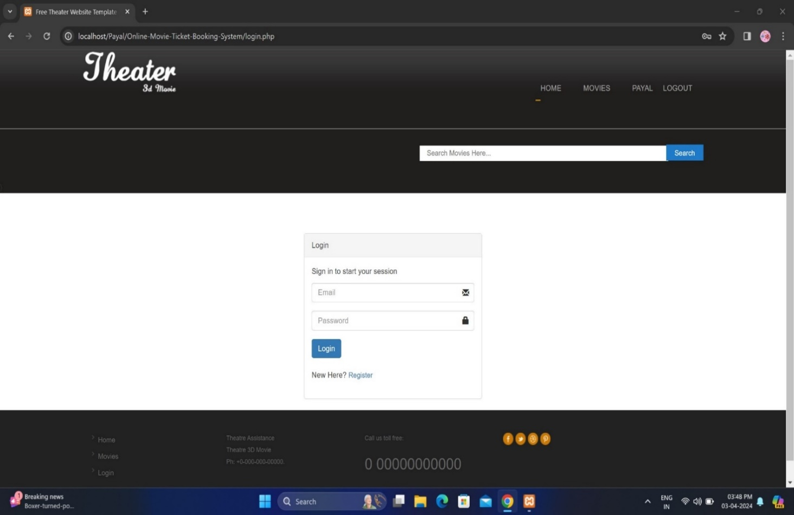

**(Main menu)**

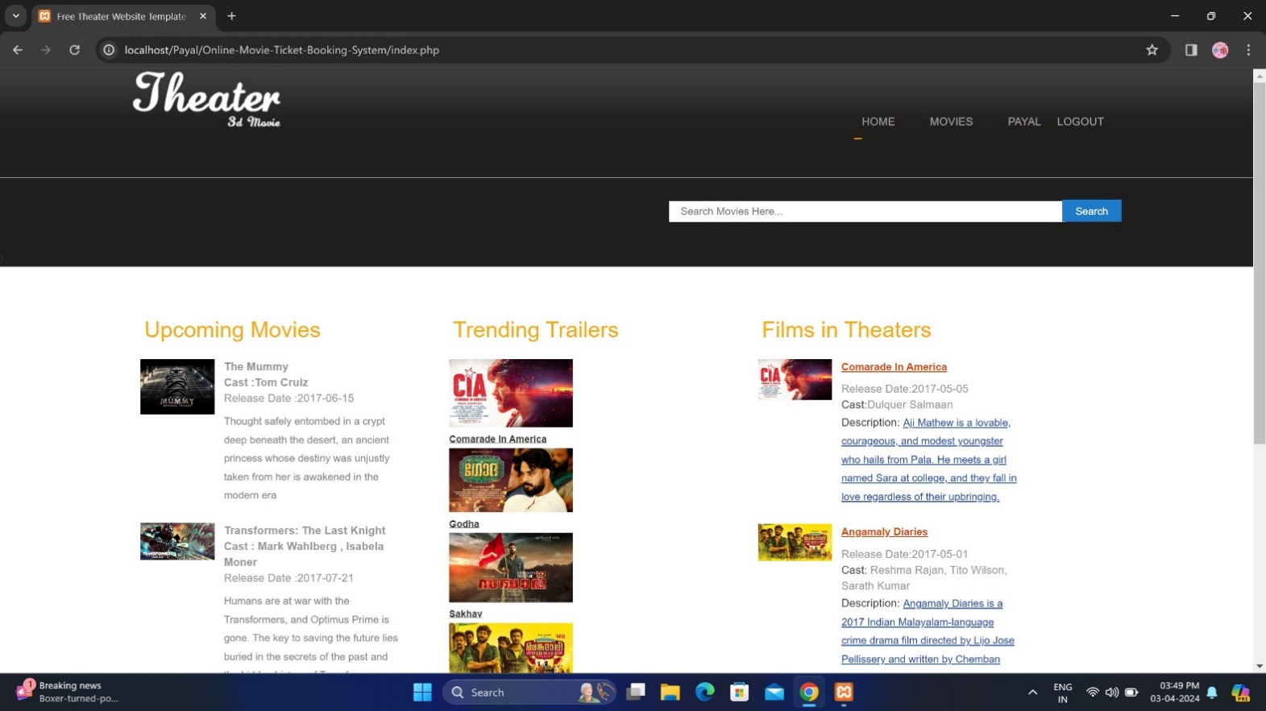

**(Movie Searching)**

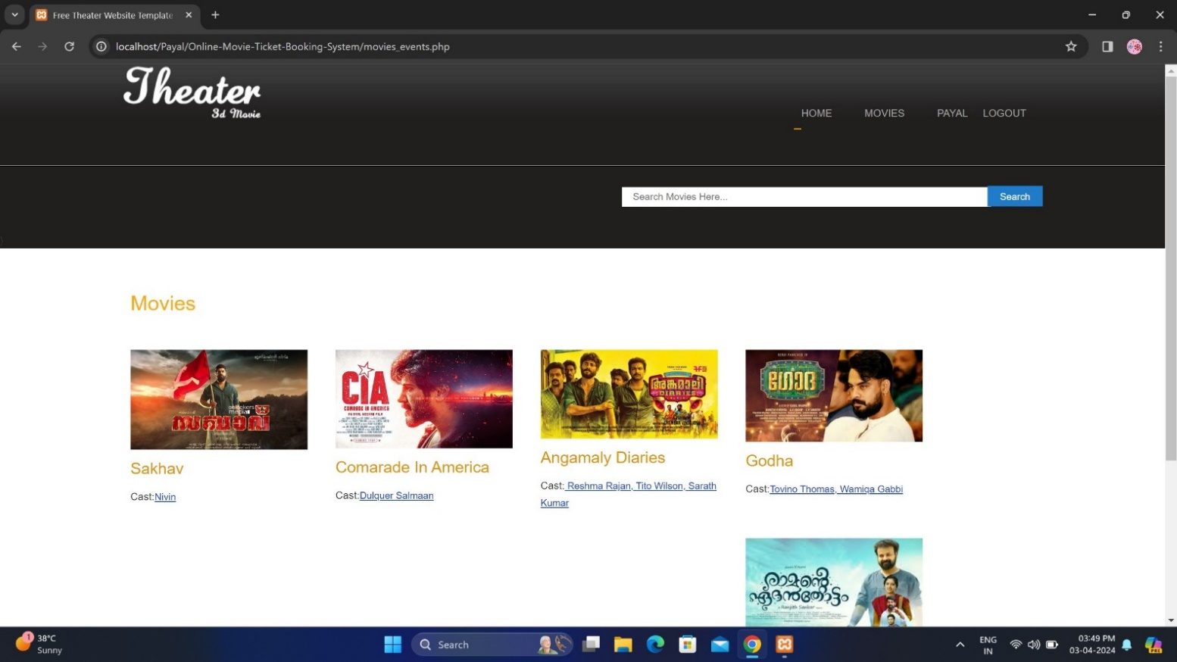

**(watch trailer)**

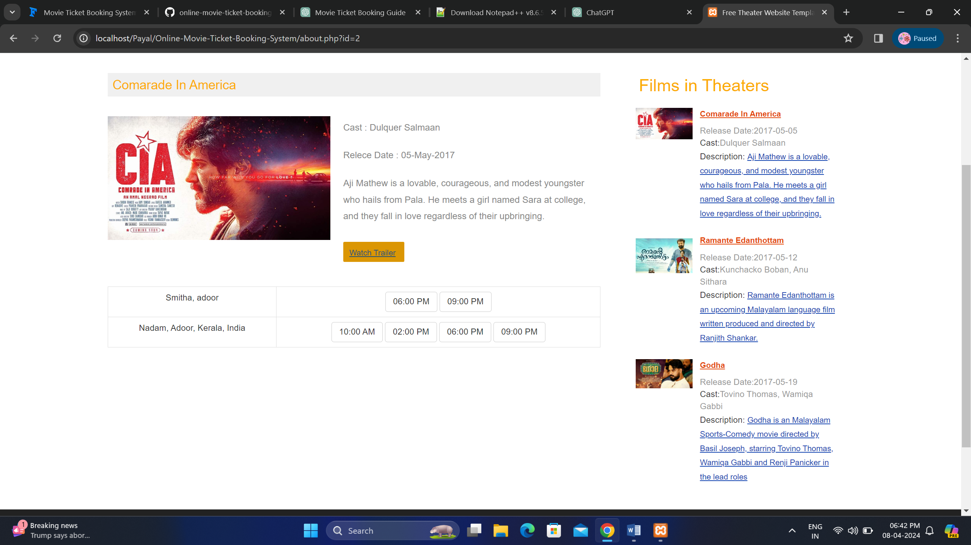

**Chapter 4**

**Sample Program code**

**4 .Sample Program code :**

<?php include('header.php');?>

</div>

<div class="content">

<div class="wrap">

<div class="content-top" style="min-height:300px;padding:50px">

<div class="col-md-4 col-md-offset-4">

<div class="panel panel-default">

<div class="panel-heading">Login</div>

<div class="panel-body">

<?php include('msgbox.php');?>

<p class="login-box-msg">Sign in to start your session</p>

<form action="process_login.php" method="post">

<div class="form-group has-feedback">

<input name="Email" type="text" size="25" placeholder="Email" class="form-control" placeholder="Email"/>

<span class="glyphicon glyphicon-envelope form-control-feedback"></span>

</div>

<div class="form-group has-feedback">

<input name="Password" type="password" size="25" placeholder="Password" class="form-control" placeholder="Password" />

<span class="glyphicon glyphicon-lock form-control-feedback"></span>

</div>

<div class="form-group">

<button type="submit" class="btn btn-primary">Login</button>

<p class="login-box-msg" style="padding-top:20px">New Here? <a href="registration.php">Register</a></p>

</div>

</div>

</div>

</form>

</div>

</div>

<div class="clear"></div>

</div>

<?php include('footer.php');?>

</div>

<html>

<body>

<?php

include('header.php');

?>

<div class="content">

<div class="wrap">

<div class="content-top">

<div class="listview_1_of_3 images_1_of_3">

<h3>Upcoming Movies</h3>

<?php

$qry3=mysqli_query($con,"select * from tbl_news");

while($n=mysqli_fetch_array($qry3))

{

?>

<div class="content-left">

<div class="listimg listimg_1_of_2">

<img src="admin/<?php echo $n['attachment'];?>">

</div>

<div class="text list_1_of_2">

<div class="extra-wrap">

<span style="text-color:#000" class="data"><strong><?php echo $n['name'];?></strong><br>

<span style="text-color:#000" class="data"><strong>Cast :<?php echo $n['cast'];?></strong><br>

<div class="data">Release Date :<?php echo $n['news_date'];?></div>

<span class="text-top"><?php echo $n['description'];?></span>

</div>

</div>

<div class="clear"></div>

</div>

<?php

}

?>

</div>

<div class="listview_1_of_3 images_1_of_3">

<h3>Trending Trailers</h3>

<div class="middle-list">

<?php

$qry4=mysqli_query($con,"select * from tbl_movie order by rand()");

while($nm=mysqli_fetch_array($qry4))

{

?>

<div class="listimg1">

<a target="_blank" href="<?php echo $nm['video_url'];?>"><img src="<?php echo $nm['image'];?>" alt=""/></a>

<a target="_blank" href="<?php echo $nm['video_url'];?>" class="link"><?php echo $nm['movie_name'];?></a>

</div>

<?php

}

?>

</div>

</div>

<?php include('movie_sidebar.php');?>

</div>

</div>

<?php include('footer.php');?>

</div>

<?php include('searchbar.php');?>

**Chapter 5**

**Menu Explanation**

**5.Menu Explanation :**

**Home**: This is the landing page where users are greeted and provided with options to explore available movies, theaters, and showtimes. It may also feature promotional content or special offers.

1. **Movies**: This menu option allows users to browse through the list of available movies. They can view details such as title, genre, language, duration, and rating. Users can select a movie to view its showtimes and book tickets.
2. **Theaters**: Users can explore the list of theaters where movies are being screened. Information such as the theater name, location, and available seating capacity may be provided. Users can select a theater to view its showtimes and book tickets.
3. **Showtimes**: This option displays the list of available showtimes for movies across different theaters. Users can see the movie title, theater name, location, and showtime schedule. They can select a showtime to proceed with ticket booking.
4. **My Bookings**: Users can view their past and upcoming bookings in this section. It provides details such as movie title, showtime, theater, number of tickets, and booking status. Users may also have the option to cancel or modify their bookings if allowed by the system.
5. **Account Settings**: This menu option allows users to manage their account settings. They can update personal information, change passwords, add or remove payment methods, and set notification preferences.
6. **Help & Support**: Users can access support resources such as FAQs, user manuals, contact information for customer support, and troubleshooting guides. They may also have the option to initiate a live chat or submit a support ticket for assistance.
7. **Sign In / Sign Up**: Users can log in to their existing account or sign up for a new account if they are new to the platform. Secure authentication methods such as email/password or social media login may be provided.
8. **Language / Region**: This option allows users to select their preferred language and region for browsing the platform. It enhances the user experience by providing content in the user's preferred language and displaying relevant regional information.
9. **Exit / Logout**: This option allows users to log out of their account and exit the application. It ensures the security of the user's account and data by terminating the session when not in use.

These menu options provide users with a seamless and intuitive experience for browsing movies, checking showtimes, and booking tickets through the Online Movie Ticket Booking System.

**Chapter 6**

**Drawbacks and Limitations**

Top of Form

**6. Drawbacks and Limitations:**

This system software is restrictive.

This system software is expensive.

This system software is not virus protected.

**Chapter 6**

**Preposed Enhancement**

**7. Preposed Enhancement:**

The system software will contain all the administrative level process in it The scope of the system is going to be globalized. The Architecture which we are using ve three tire architecture

This system software is user friendly and attractive, so that it is become easy for handle.

The process is going on to make this system web base.

**Chapter 8**

**Conchesions**

**8. Conchesions:**

The Centralised Project Development System has been developed with due sincerity and diligence by following standard development practices. The system delivers the functionality as required by the user to his utmost satisfaction. The system has proved for the organization for popularity berween Managers, Customer and Admin

The Centralized Project Development System is proposed for online Movie Ticket Booking system. This system is helps to user for handle Booking Movie Ticker details.

**Chapter 9**

**Bibliography**

**9.Bibliography:**

Sites referred:-

1.www.google.com

2. [www.w3school.com](http://www.w3school.com)

<?php

session start(),

S SESSION['show']=$_GET['show'];

$_SESSION['movie']=$_GET['movie'];

S SESSION['theatre']=$_GET['theatre'];

if(isset($_SESSION['user']))

{

header('location booking.php');

}

else

{

Header('location:login.php');

}

?>